LAB EXPERIMENTS

NAME: MAMIDI MANASA REG NO: 192425189
COURSE CODE: ITA0512 COURSE NAME: COMPUTER VISION
1.Perform basic Image Handling and processing operations on the image is to read an image in python and Convert an Image to Gray-scale.
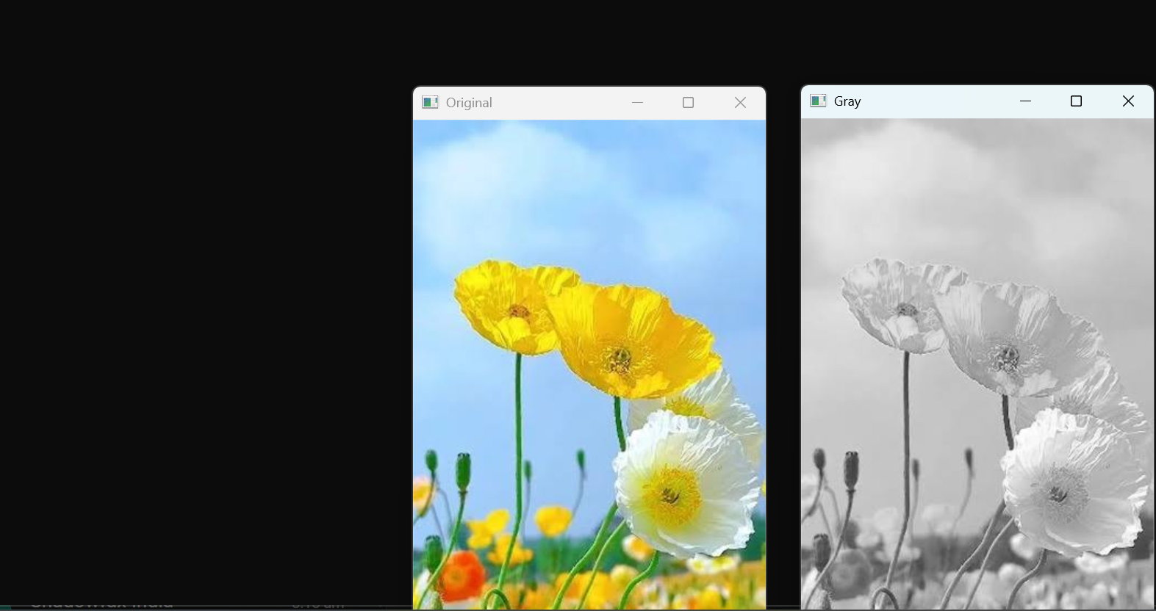

2. Perform basic Image Handling and processing operations on the image is to read an image in
python and Convert an Image to Blur using Gaussian Blur
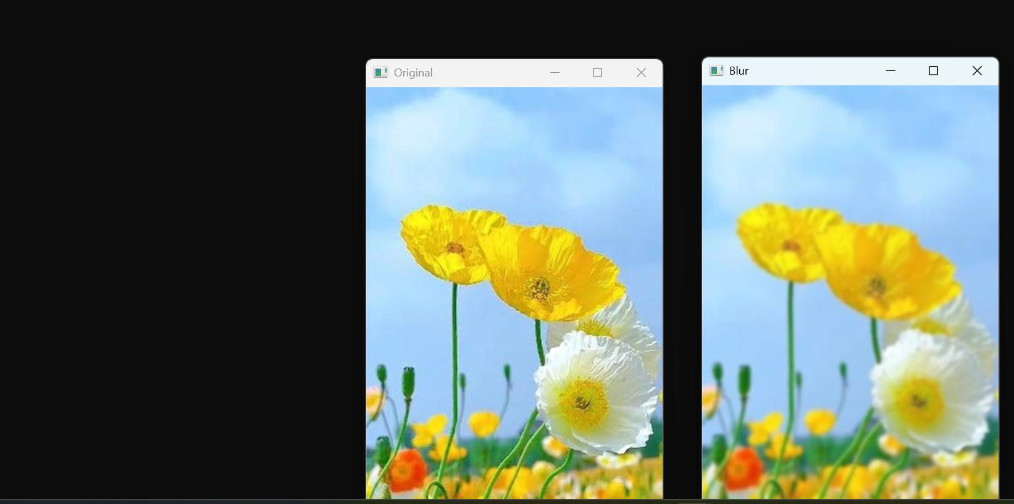

3.Perform basic Image Handling and processing operations on the image is to read an image in
python and Convert an Image to show outline using Canny function.
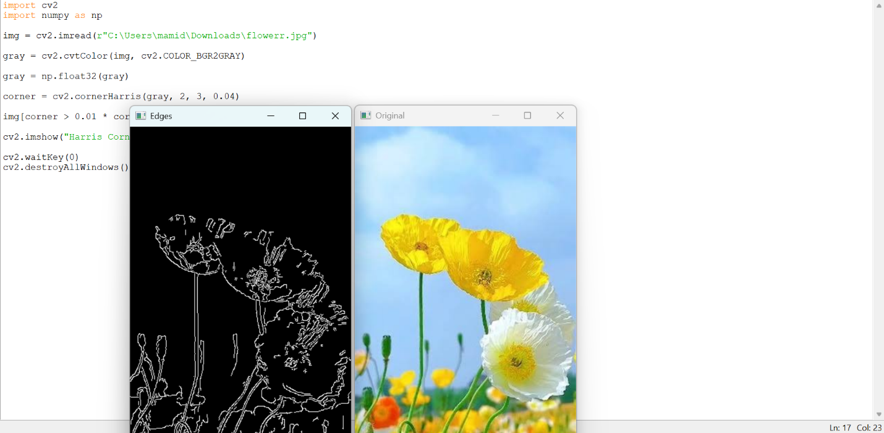

4.Implement histogram equalization on the given image and compare it with the original image
using Open CV.
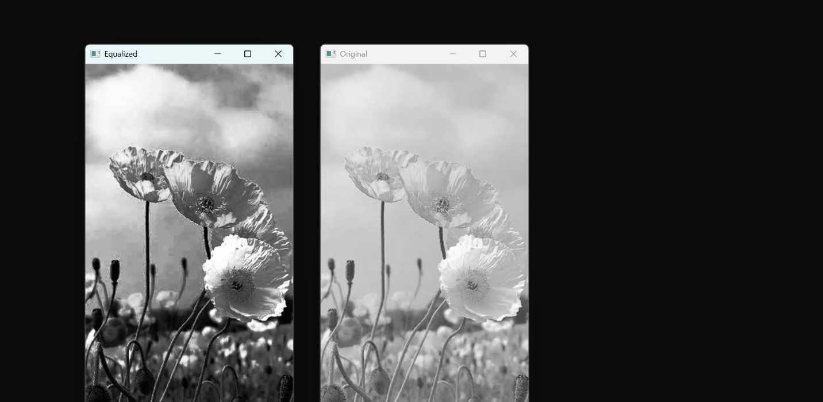

5.Write a Python function to analyze the histogram of the given input image based on color
levels using Open CV.
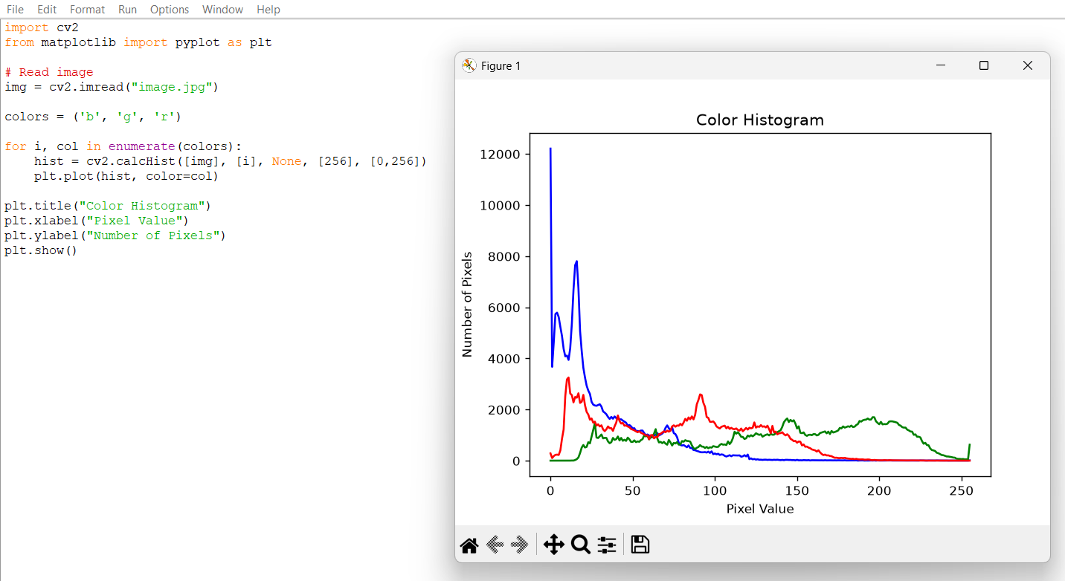
6.Perform basic Image Handling and processing operations on the image is to read an image in python and Convert an Image to erode using Erode function.
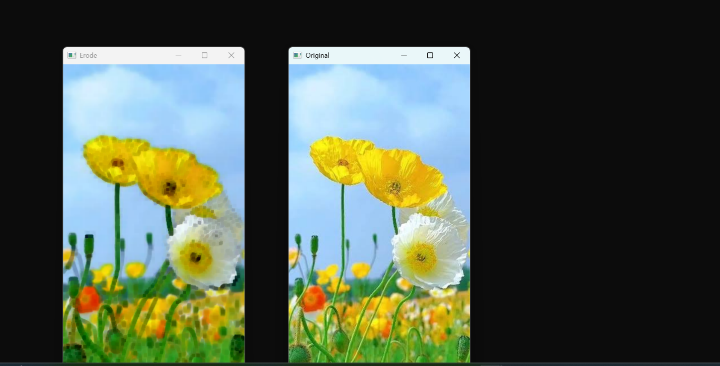

7.Perform basic video processing operations on the captured video. Read captured video in
python and display the video, in slow motion and in fast motion.
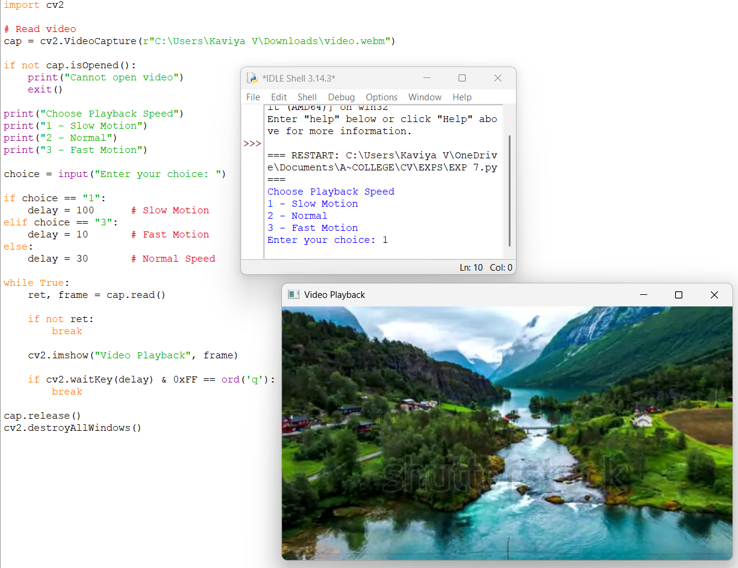
8.Perform basic Image Handling and processing operations on the image is to read an image in
python and Dilate an Image using Dilate function
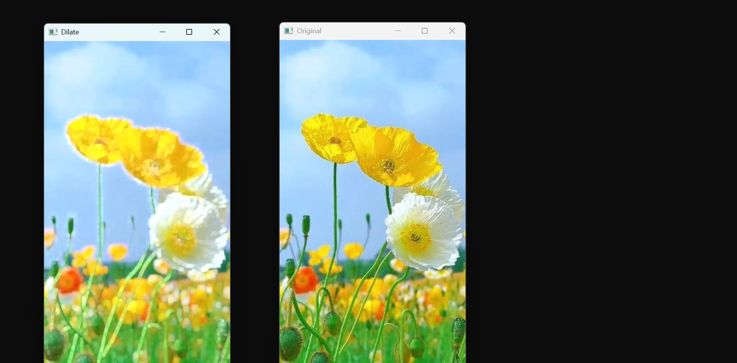
9.Implement the image scaling techniques to resize the images to both bigger and small sizes
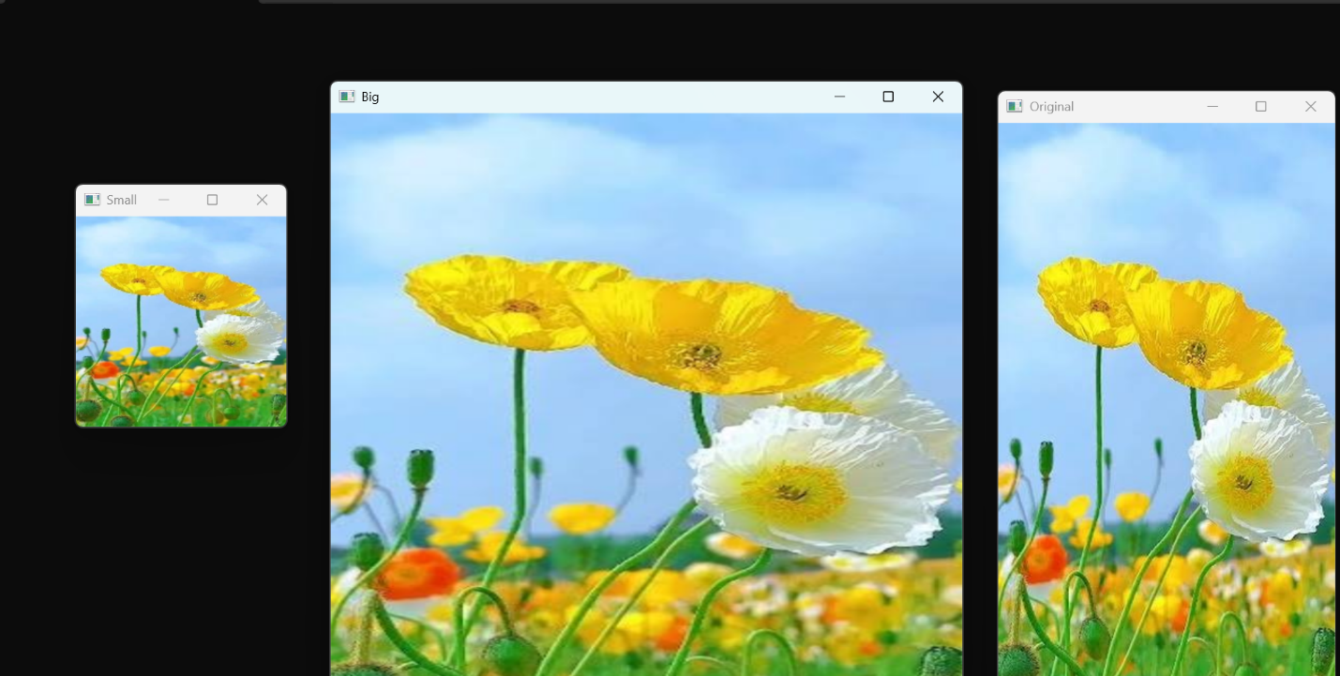
10.Perform a 90-degree rotation clockwise along the y-axis for the given image.
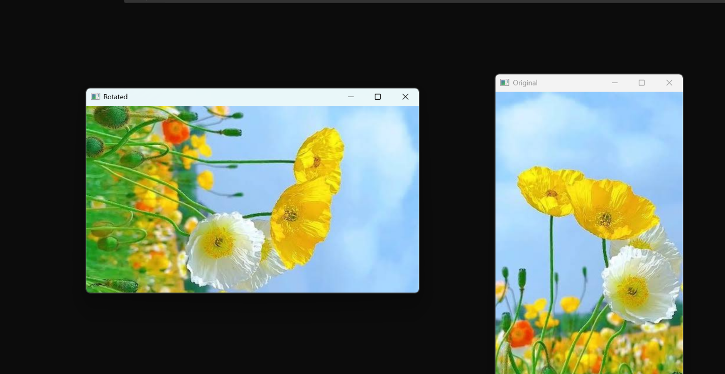

11 .Perform a 180-degree rotation clockwise along the y-axis for the given image.
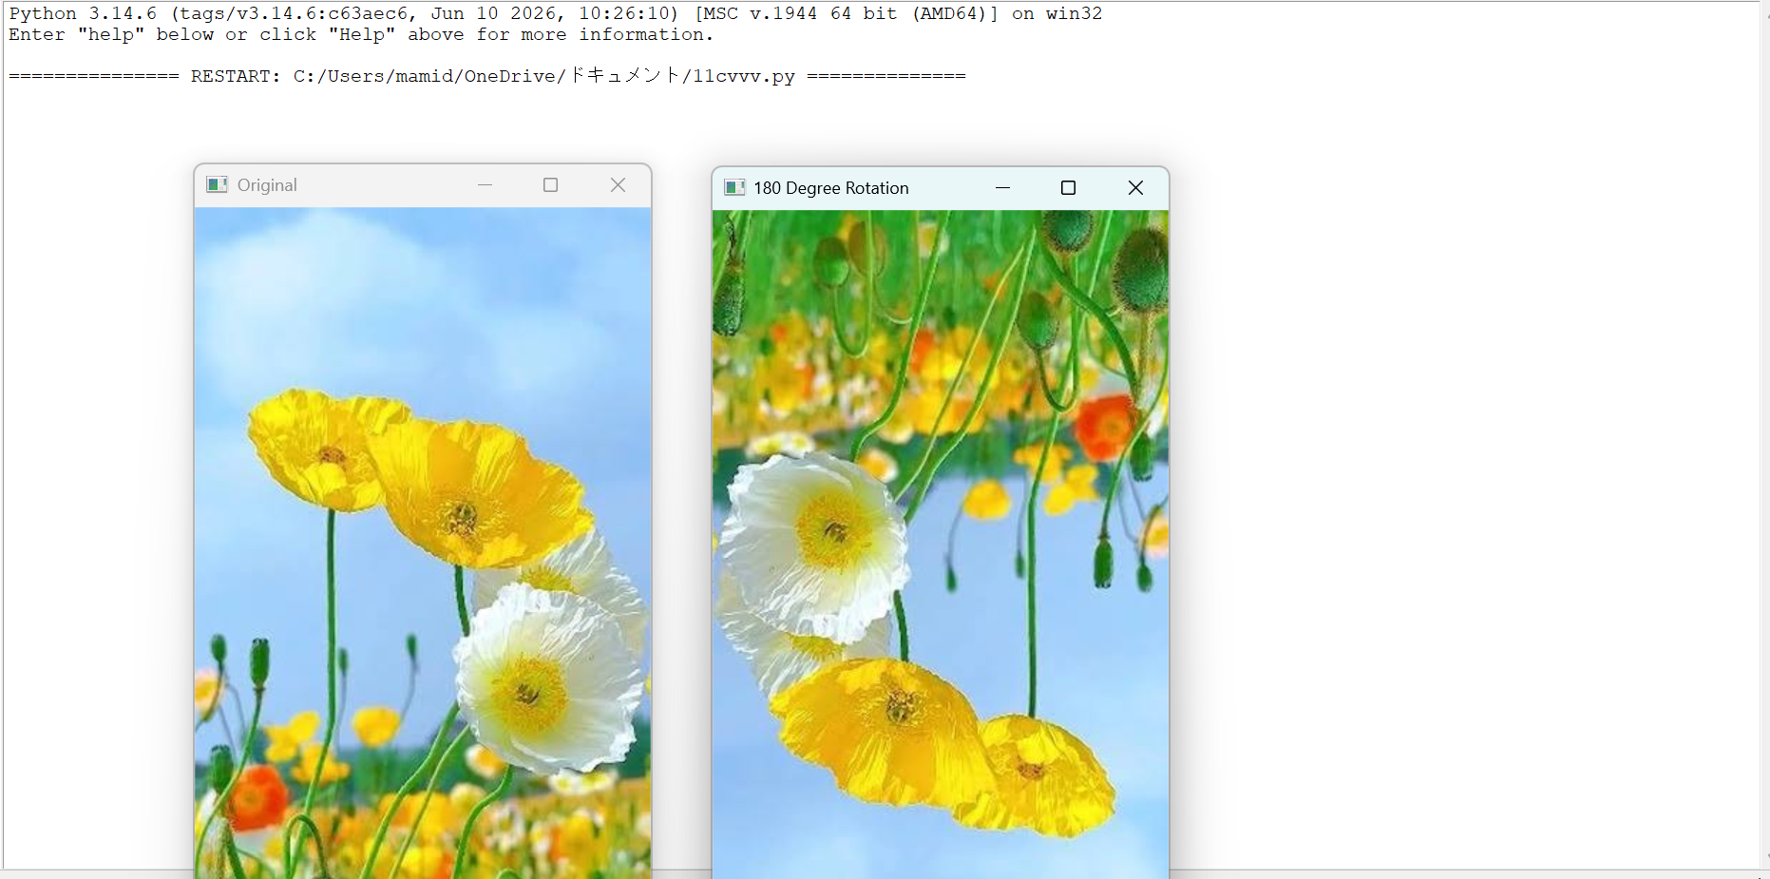

12.Perform a 270-degree rotation clockwise along the y-axis for the given image.
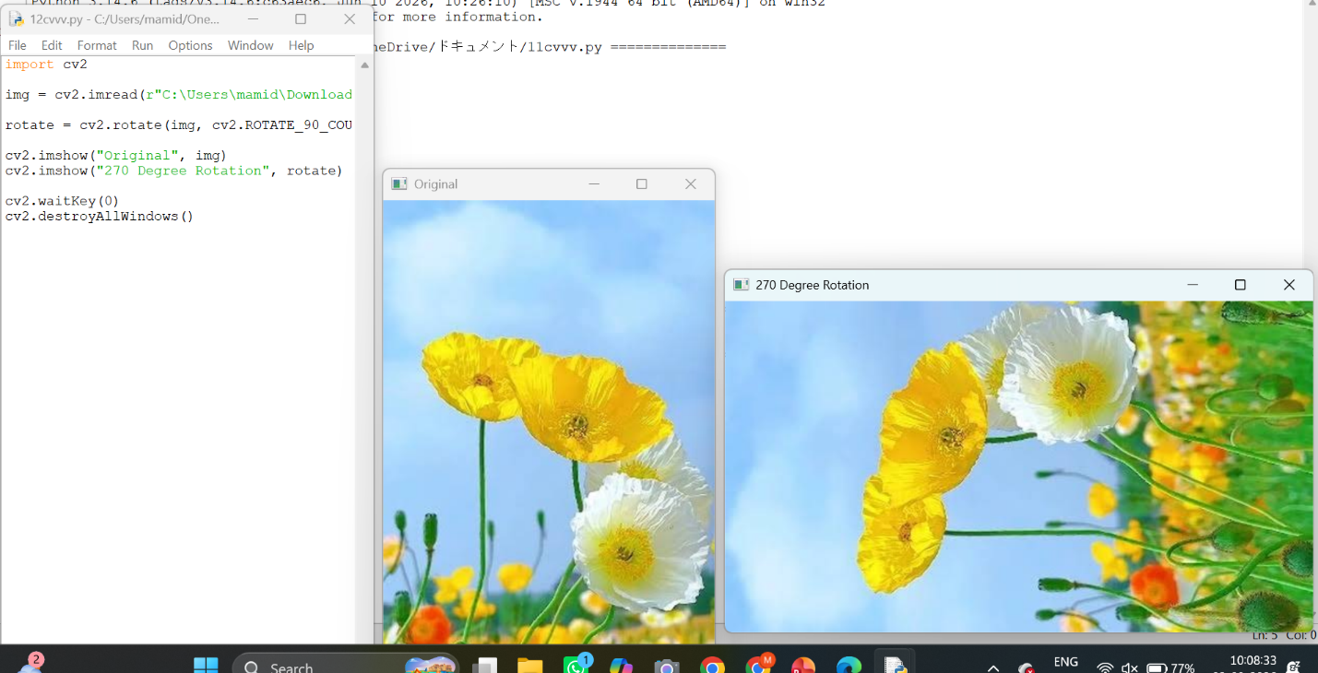

13.Perform Affine Transformation on the given image using python and Open CV
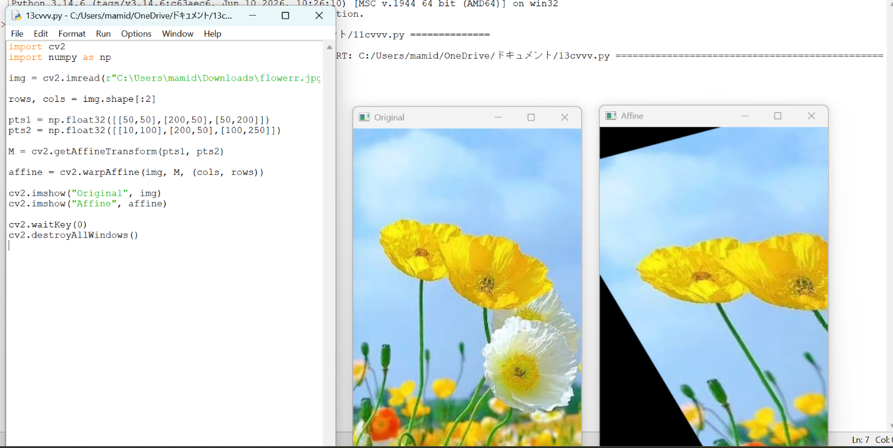
14.Perform Perspective Transformation on the given image using python and Open CV.
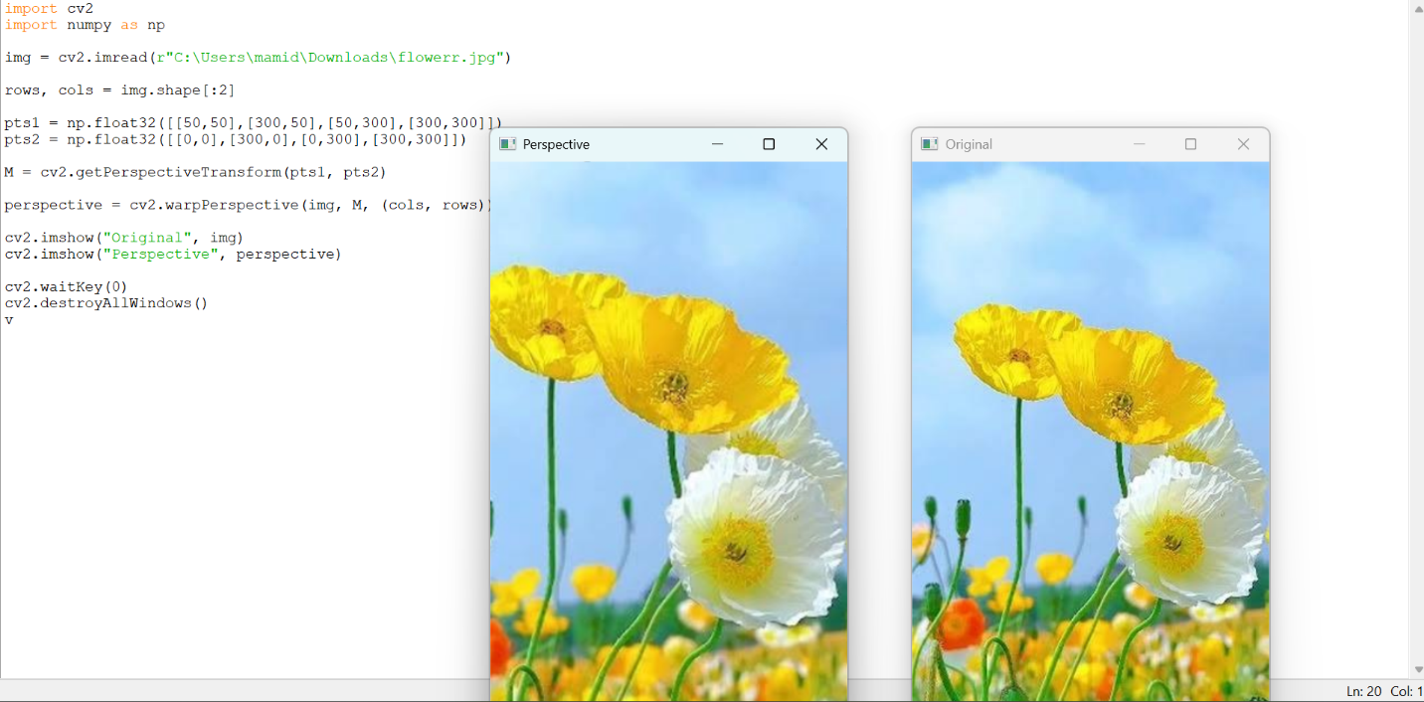
15.Perform basic Image Handling and processing operations on the image is to read an image in
python and detect the corners in the image using Harris Corner Detection function
